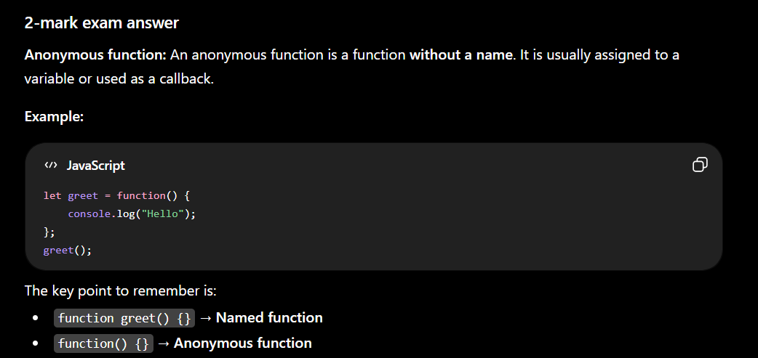

1. Named Function
A named function has a function name after the function keyword.
function greet() {
console.log("Hello");
}

greet();
Here,
- function → keyword
- greet → function name ✅
- { } → function body

2. Anonymous Function
An anonymous function has no name after the function keyword.
let greet = function() {
console.log("Hello");
};

greet();
Here,
- function → keyword
- No name here ❌
- greet is not the function's name. It is only a variable that stores the function.
Think of it like this:
let x = 10;
Here, 10 has no name. It is just stored in the variable x.
Similarly,
let greet = function() {
console.log("Hello");
};
The anonymous function has no name. It is simply stored in the variable greet.

Side-by-side comparison
Named Function | Anonymous Function
function greet() {} | function() {}
Has a function name (greet) | No function name
Called by greet() | Stored in a variable, then called using that variable (greet())

Highlighting the difference
Named Function
function greet() {
console.log("Hello");
}
greet ← Function name ✅

Anonymous Function
let greet = function() {
console.log("Hello");
};
Notice this part:
function() // No name here
There is nothing between function and (), so it is an anonymous function.
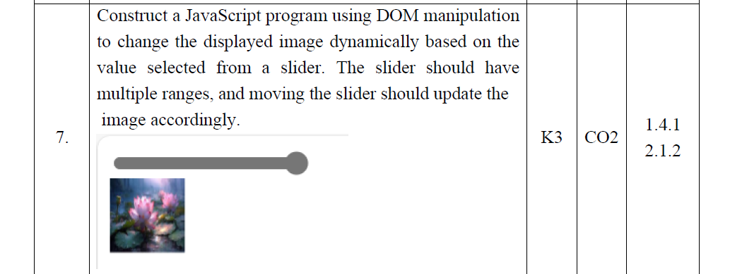

DOM tree Basics
https://chatgpt.com/c/6a613d5e-8c00-83e8-b2b9-ccf0f67fd470
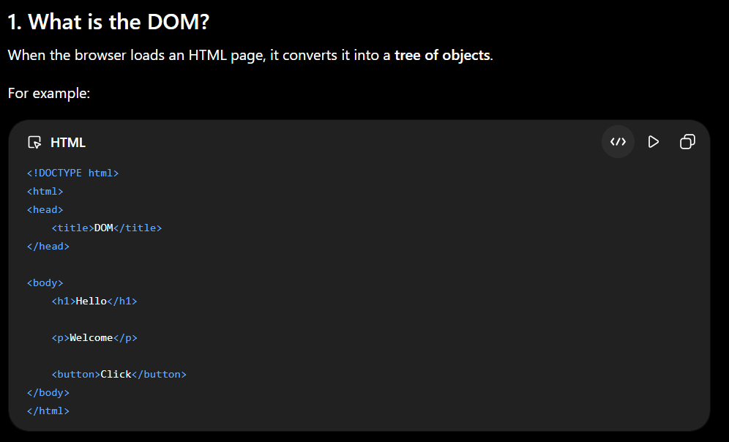
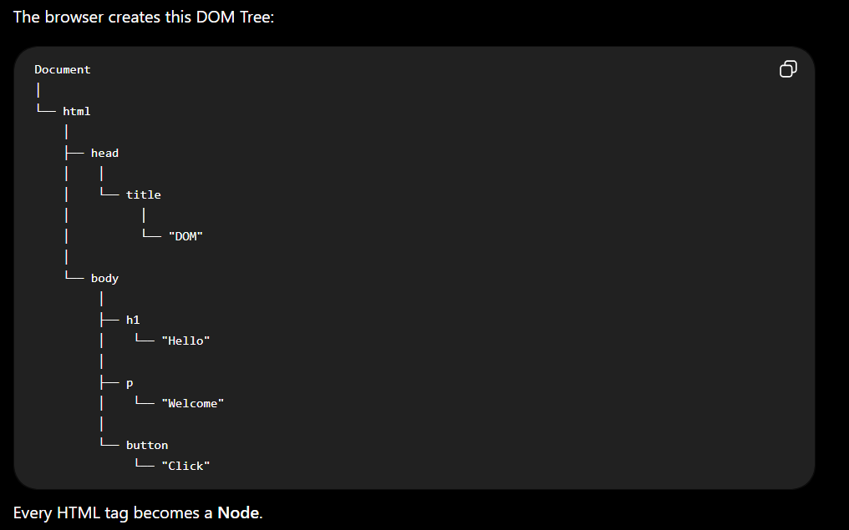

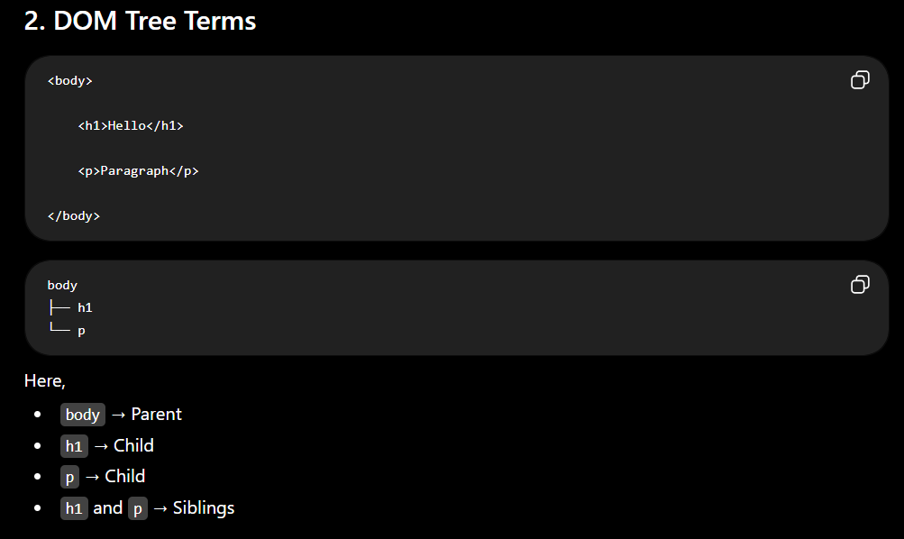

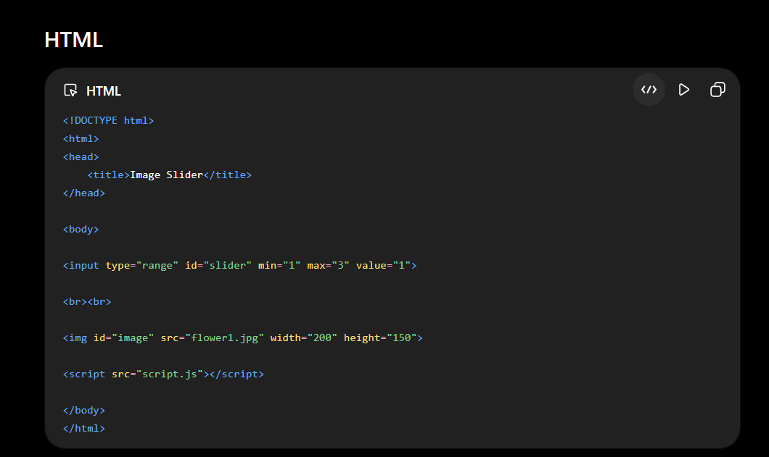
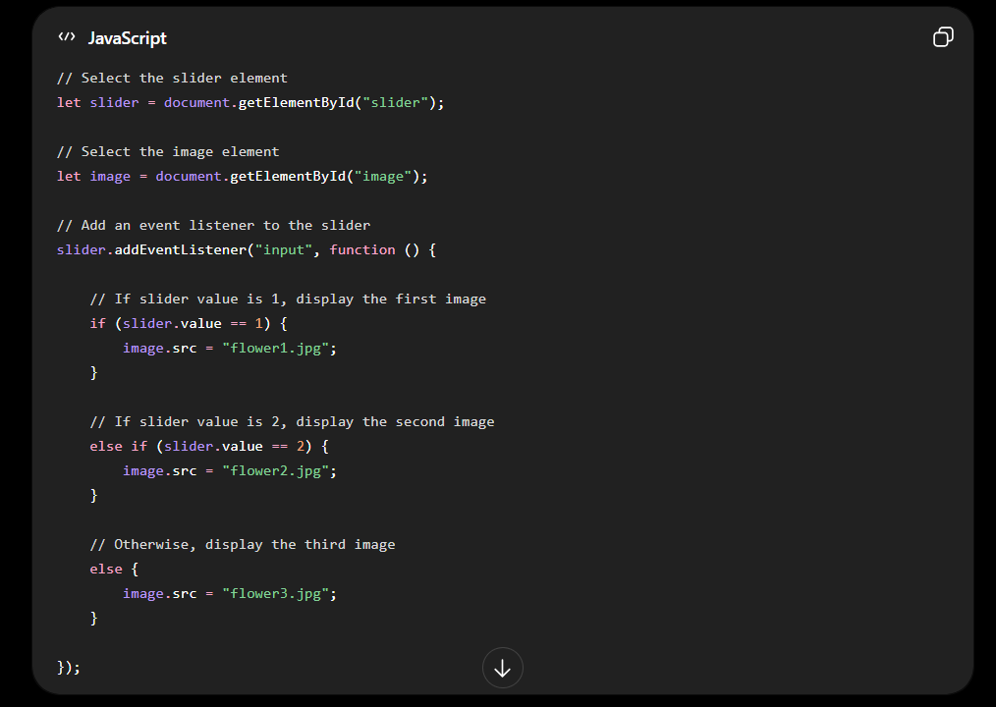

6-mark DOM manipulation question, your answer should include:
- HTML
- CSS (optional but neat)
- JavaScript using DOM
- Output/Explanation

HTML
<!DOCTYPE html>
<html>
<head>
<title>Image Slider</title>
</head>
<body>

<input type="range" id="slider" min="1" max="3" value="1">

<br><br>

<img id="image" src="flower1.jpg" width="200" height="150">

<script src="script.js"></script>

</body>
</html>

JavaScript (script.js)
let slider = document.getElementById("slider");
let image = document.getElementById("image");

slider.addEventListener("input", function () {

if (slider.value == 1) {
image.src = "flower1.jpg";
}
else if (slider.value == 2) {
image.src = "flower2.jpg";
}
else {
image.src = "flower3.jpg";
}

});

How it works
let slider = document.getElementById("slider");
Gets the slider from the HTML.

let image = document.getElementById("image");
Gets the image element.

slider.addEventListener("input", function () {
Whenever the slider moves, this function executes.

if (slider.value == 1)
If slider is at 1, display the first image.

else if (slider.value == 2)
If slider is at 2, display the second image.

else
Otherwise display the third image.

image.src = "flower2.jpg";
Changes the image using DOM manipulation.

Output
Slider Position | Image Displayed
1 | flower1.jpg
2 | flower2.jpg
3 | flower3.jpg

Exam Explanation (6 Marks)
Program: Uses DOM manipulation to dynamically change the displayed image based on the slider value.
- getElementById() selects the slider and image elements.
- addEventListener("input") detects slider movement.
- if...else checks the slider value.
- image.src changes the image dynamically.

UNDERSTANDING
Difference between fun(), fun, and function(){}
Syntax | Meaning | When is it used?
fun() | Calls the function immediately | Use when you want to execute the function now.
fun | Function reference (does not call it) | Use when passing a named function to addEventListener().
function(){} | Anonymous function (no name) | Use when the function is needed only once, usually inside addEventListener().

Example 1 – Immediate Function Call
function fun() {
alert("Hello");
}

fun();
Meaning:
Execute the function immediately.

Example 2 – Named Function in addEventListener()
function fun() {
alert("Hello");
}

button.addEventListener("click", fun);
Meaning:
When the button is clicked, execute fun().

Example 3 – Anonymous Function in addEventListener()
button.addEventListener("click", function () {
alert("Hello");
});
Meaning:
When the button is clicked, execute this anonymous function.

Named Function vs Anonymous Function
Named Function | Anonymous Function
Has a name | No name
Can be called multiple times | Usually used only once
Example: function fun(){} | Example: function(){}

Easy Memory Trick
fun() → Run NOW

fun → Run LATER (when event occurs)

function(){} → Anonymous function, run LATER

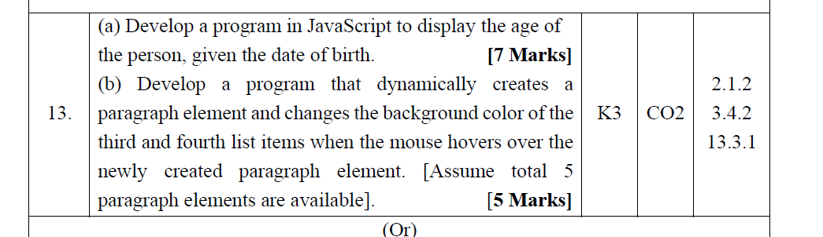

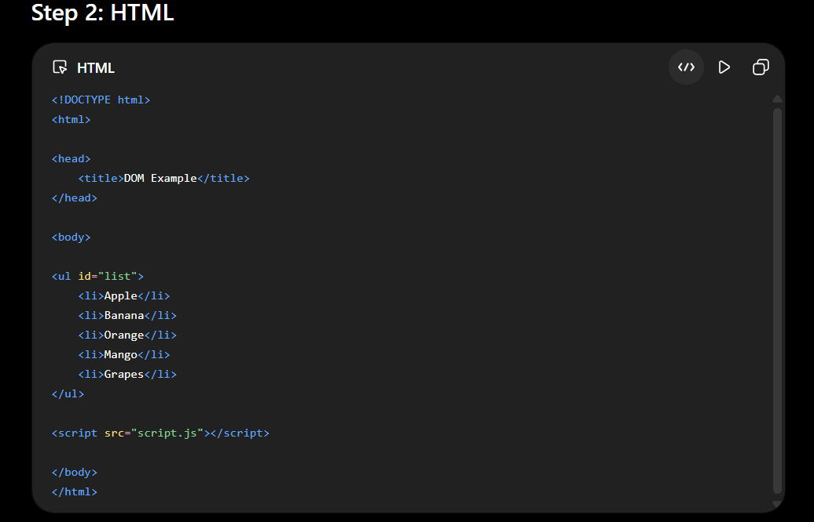
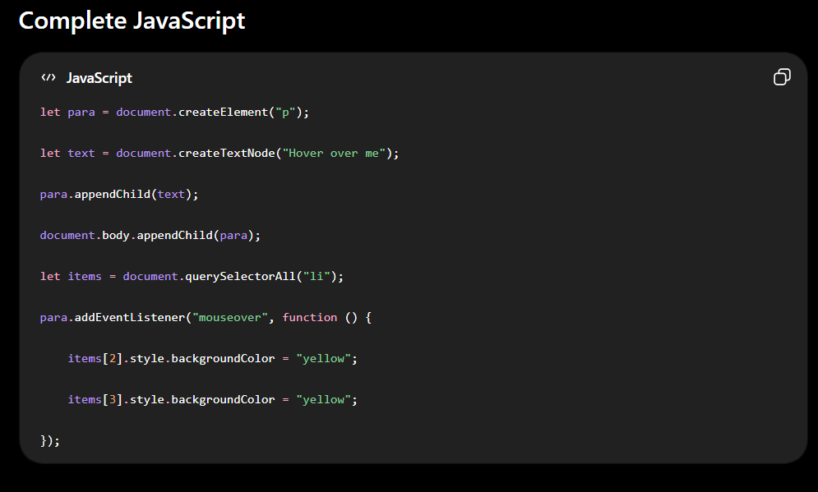
This is a classic DOM Manipulation + Events question. Your professor is testing whether you know:
- ✅ createElement()
- ✅ createTextNode()
- ✅ appendChild()
- ✅ addEventListener()
- ✅ querySelectorAll()
- ✅ style.backgroundColor
Let's solve it step by step.

Question
Develop a program that dynamically creates a paragraph element and changes the background color of the third and fourth list items when the mouse hovers over the newly created paragraph element.
Assume
- 5 list items already exist.

Step 1: Understand the Question
Initially
Item 1
Item 2
Item 3
Item 4
Item 5
No paragraph exists.
When the page loads,
JavaScript should create
<p>Hover over me</p>
When the mouse moves over that paragraph,
Item 3 → Yellow
Item 4 → Yellow

Step 2: HTML
<!DOCTYPE html>
<html>

<head>
<title>DOM Example</title>
</head>

<body>

<ul id="list">
<li>Apple</li>
<li>Banana</li>
<li>Orange</li>
<li>Mango</li>
<li>Grapes</li>
</ul>

<script src="script.js"></script>

</body>
</html>
Notice
There is NO paragraph.
We must create it using JavaScript.

Step 3: Create Paragraph
let para = document.createElement("p");
What happens?
Memory
<p></p>
Not visible.

Step 4: Create Text Node
let text = document.createTextNode("Hover over me");
Memory
"Hover over me"
Still invisible.

Step 5: Put Text Inside Paragraph
para.appendChild(text);
Memory
<p>

Hover over me

</p>
Still invisible.

Step 6: Add Paragraph to Webpage
document.body.appendChild(para);
Now
Apple

Banana

Orange

Mango

Grapes

Hover over me
Paragraph becomes visible.

Step 7: Select All List Items
let items = document.querySelectorAll("li");
This returns
items[0] → Apple

items[1] → Banana

items[2] → Orange

items[3] → Mango

items[4] → Grapes
Remember
Arrays start from 0.
So
Third item
↓
items[2]
Fourth item
↓
items[3]

Step 8: Add Mouse Event
para.addEventListener("mouseover", function () {

});
Meaning
When mouse enters paragraph,

run this code.

Step 9: Change Background
items[2].style.backgroundColor = "yellow";

items[3].style.backgroundColor = "yellow";

Complete JavaScript
let para = document.createElement("p");

let text = document.createTextNode("Hover over me");

para.appendChild(text);

document.body.appendChild(para);

let items = document.querySelectorAll("li");

para.addEventListener("mouseover", function () {

items[2].style.backgroundColor = "yellow";

items[3].style.backgroundColor = "yellow";

});

Memory Flow

Initially
Memory

↓

Nothing

createElement()
Memory

↓

<p></p>

createTextNode()
Memory

↓

<p></p>

"Hover over me"

appendChild()
Memory

↓

<p>

Hover over me

</p>

body.appendChild()
DOM

↓

Apple

Banana

Orange

Mango

Grapes

Hover over me

Mouse Over
Mouse enters paragraph

↓

mouseover event

↓

Anonymous function executes

↓

3rd item becomes yellow

↓

4th item becomes yellow

Line-by-Line Explanation (6 Marks)

1.
let para = document.createElement("p");
Creates a paragraph element in memory.

2.
let text = document.createTextNode("Hover over me");
Creates a text node.

3.
para.appendChild(text);
Adds the text node inside the paragraph.

4.
document.body.appendChild(para);
Adds the paragraph to the webpage.

5.
let items = document.querySelectorAll("li");
Selects all <li> elements.

6.
para.addEventListener("mouseover", function () {
Executes the function when the mouse enters the paragraph.

7.
items[2].style.backgroundColor = "yellow";
Changes the background color of the third list item.

8.
items[3].style.backgroundColor = "yellow";
Changes the background color of the fourth list item.

Viva Questions
Q1. Why do we use createElement()?
To create a new HTML element dynamically using JavaScript.

Q2. Why do we use createTextNode()?
To create a text node that can be inserted into an HTML element.

Q3. Why is appendChild() used twice?
The first appendChild() adds the text node to the paragraph. The second appendChild() adds the paragraph to the webpage.

Q4. Why items[2] and items[3]?
Because array indexing starts from 0, so the third and fourth list items are at indexes 2 and 3.

Q5. Why use mouseover?
The mouseover event is triggered when the mouse pointer enters the paragraph element. This event is used to change the background color of the required list items.

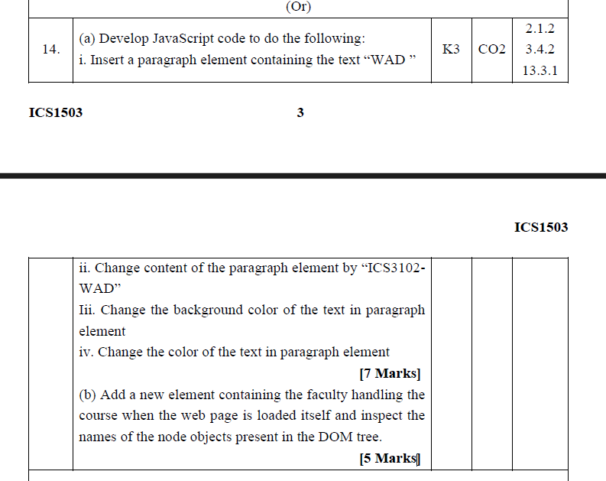

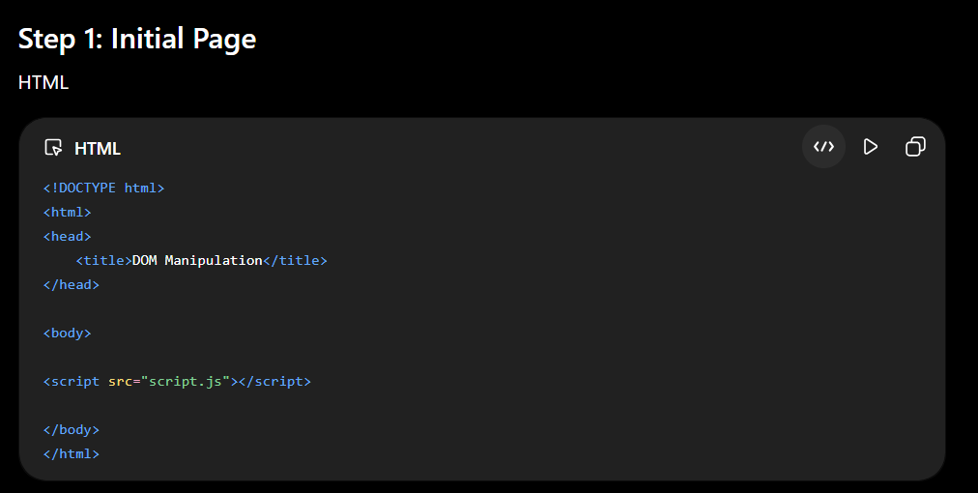
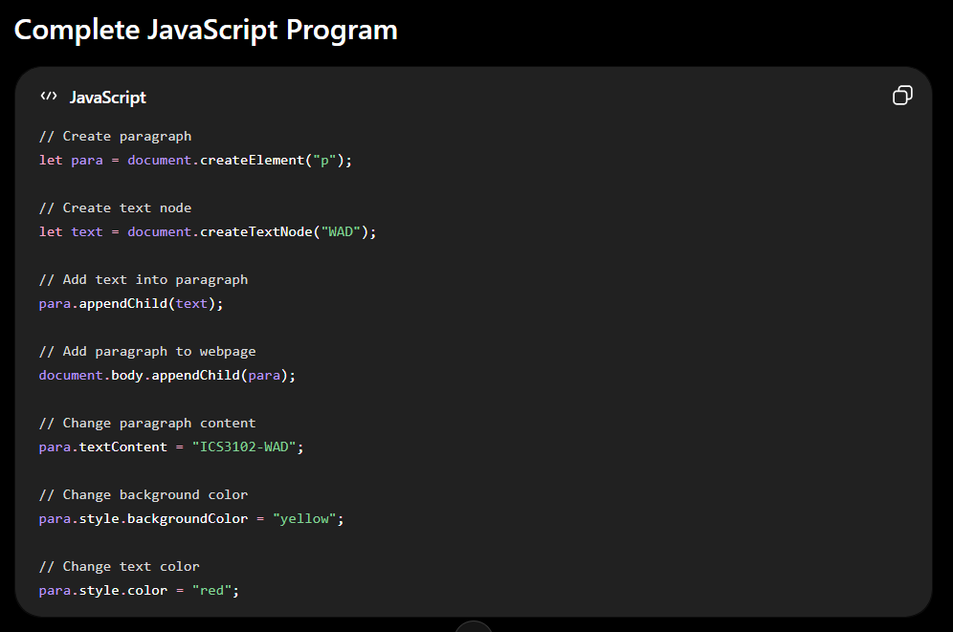

This is actually an easy 7-mark DOM question. The examiner is checking whether you know:
- ✅ createElement()
- ✅ createTextNode()
- ✅ appendChild()
- ✅ textContent / innerHTML
- ✅ style.backgroundColor
- ✅ style.color
Let's solve it step by step.

Question
Write JavaScript code to
- Insert a paragraph containing "WAD"
- Change it to "ICS3102-WAD"
- Change the background color
- Change the text color

Step 1: Initial Page
HTML
<!DOCTYPE html>
<html>
<head>
<title>DOM Manipulation</title>
</head>

<body>

<script src="script.js"></script>

</body>
</html>
Notice
There is no paragraph.
JavaScript must create it.

Step 2: Create Paragraph
let para = document.createElement("p");
Memory
<p></p>
Still invisible.

Step 3: Create Text Node
let text = document.createTextNode("WAD");
Memory
"WAD"
Still invisible.

Step 4: Put Text Inside Paragraph
para.appendChild(text);
Memory
<p>

WAD

</p>
Still invisible.

Step 5: Add Paragraph to Webpage
document.body.appendChild(para);
Output
WAD
Visible now.

Step 6: Change Paragraph Content
Question says
Change content to
ICS3102-WAD
We use
para.textContent = "ICS3102-WAD";
Now
ICS3102-WAD
appears.
You can also use
para.innerHTML = "ICS3102-WAD";
Both are correct here because it is plain text.

Step 7: Change Background Color
para.style.backgroundColor = "yellow";
Output
🟨 ICS3102-WAD

Step 8: Change Text Color
para.style.color = "red";
Output
Yellow Background

Red Text

ICS3102-WAD

Complete JavaScript Program
// Create paragraph
let para = document.createElement("p");

// Create text node
let text = document.createTextNode("WAD");

// Add text into paragraph
para.appendChild(text);

// Add paragraph to webpage
document.body.appendChild(para);

// Change paragraph content
para.textContent = "ICS3102-WAD";

// Change background color
para.style.backgroundColor = "yellow";

// Change text color
para.style.color = "red";

Memory Flow

createElement()
Memory

↓

<p></p>

createTextNode()
Memory

↓

<p></p>

"WAD"

appendChild()
Memory

↓

<p>

WAD

</p>

body.appendChild()
DOM

↓

WAD

textContent
DOM

↓

ICS3102-WAD

backgroundColor
Yellow Background

color
Red Text

Line-by-Line Explanation (7 Marks)

1.
let para = document.createElement("p");
Creates a paragraph element in memory.

2.
let text = document.createTextNode("WAD");
Creates a text node containing "WAD".

3.
para.appendChild(text);
Adds the text node inside the paragraph.

4.
document.body.appendChild(para);
Displays the paragraph on the webpage.

5.
para.textContent = "ICS3102-WAD";
Changes the paragraph text dynamically.

6.
para.style.backgroundColor = "yellow";
Changes the paragraph's background color.

7.
para.style.color = "red";
Changes the paragraph's text color.

Good. Let's use only addEventListener(). We'll avoid onload="" completely so it matches what you're studying.

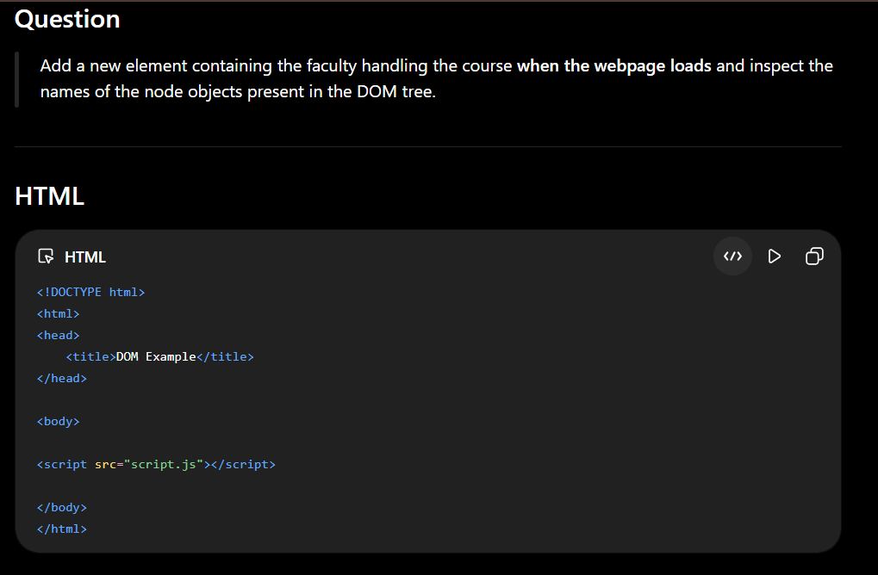
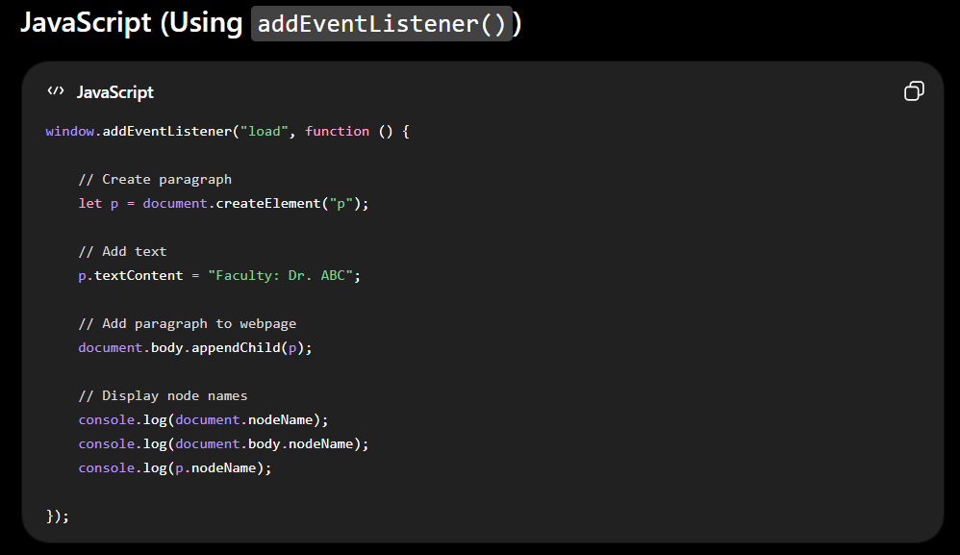

Question
Add a new element containing the faculty handling the course when the webpage loads and inspect the names of the node objects present in the DOM tree.

HTML
<!DOCTYPE html>
<html>
<head>
<title>DOM Example</title>
</head>

<body>

<script src="script.js"></script>

</body>
</html>

JavaScript (Using addEventListener())
window.addEventListener("load", function () {

// Create paragraph
let p = document.createElement("p");

// Add text
p.textContent = "Faculty: Dr. ABC";

// Add paragraph to webpage
document.body.appendChild(p);

// Display node names
console.log(document.nodeName);
console.log(document.body.nodeName);
console.log(p.nodeName);

});

Line-by-Line Explanation

1.
window.addEventListener("load", function () {
Meaning
- Wait until the webpage is completely loaded.
- Then execute the anonymous function.
Think of it as:
Webpage Loads
↓
"load" event occurs
↓
Function executes

2.
let p = document.createElement("p");
Creates a <p> element in memory.

3.
p.textContent = "Faculty: Dr. ABC";
Adds the text inside the paragraph.
Now in memory:
<p>Faculty: Dr. ABC</p>

4.
document.body.appendChild(p);
Adds the paragraph to the webpage.
Output:
Faculty: Dr. ABC

5.
console.log(document.nodeName);
Output
#document
Because document is the Document Node.

6.
console.log(document.body.nodeName);
Output
BODY
Because it is the <body> element.

7.
console.log(p.nodeName);
Output
P
Because p is a paragraph element.

Output on Webpage
Faculty: Dr. ABC
Console Output
#document
BODY
P

Viva Questions

Q. Why do we use "load"?
Answer:
The "load" event occurs after the entire webpage has loaded. It ensures that the DOM is ready before executing the JavaScript code.

Q. Why do we use window.addEventListener("load", ...)?
Answer:
It attaches a listener to the window and executes the function automatically when the page finishes loading.

Q. What does nodeName return?
Answer:
nodeName returns the name of the DOM node.
Examples:
Statement | Output
document.nodeName | #document
document.body.nodeName | BODY
p.nodeName | P

💡 Exam Tip
For your lab exam, remember this pattern whenever you see "when the page loads":
window.addEventListener("load", function () {

// Your DOM manipulation code

});
It is the modern equivalent of:
<body onload="loadPage()">
and is the recommended approach using addEventListener().

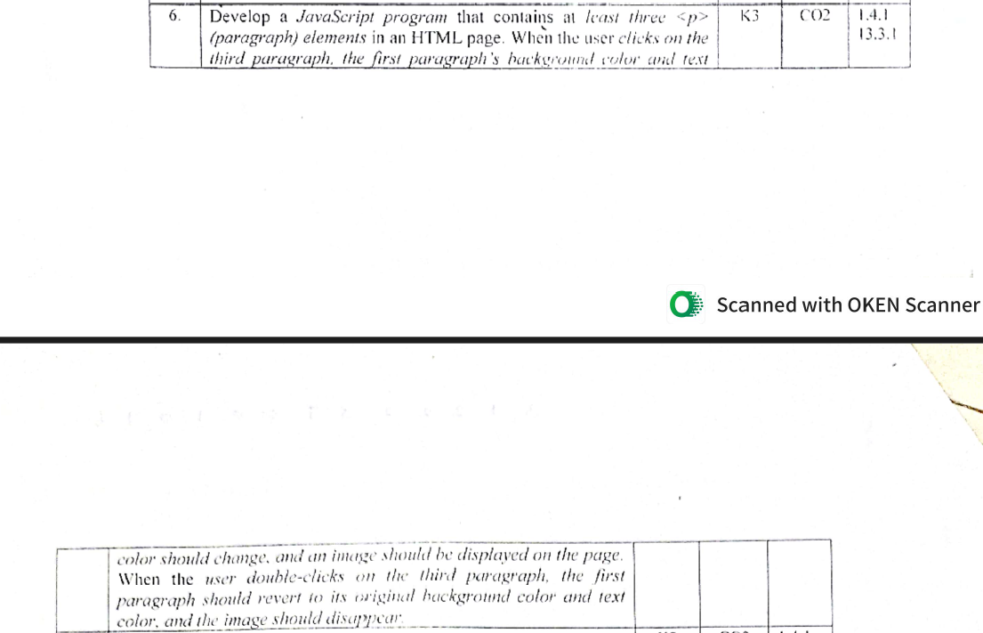

6. Develop a JavaScript program that contains at least three <p> (paragraph) elements in an HTML page. When the user clicks on the third paragraph, the first paragraph's background color and text color should change, and an image should be displayed on the page. When the user double-clicks on the third paragraph, the first paragraph should revert to its original background color and text color, and the image should disappear.

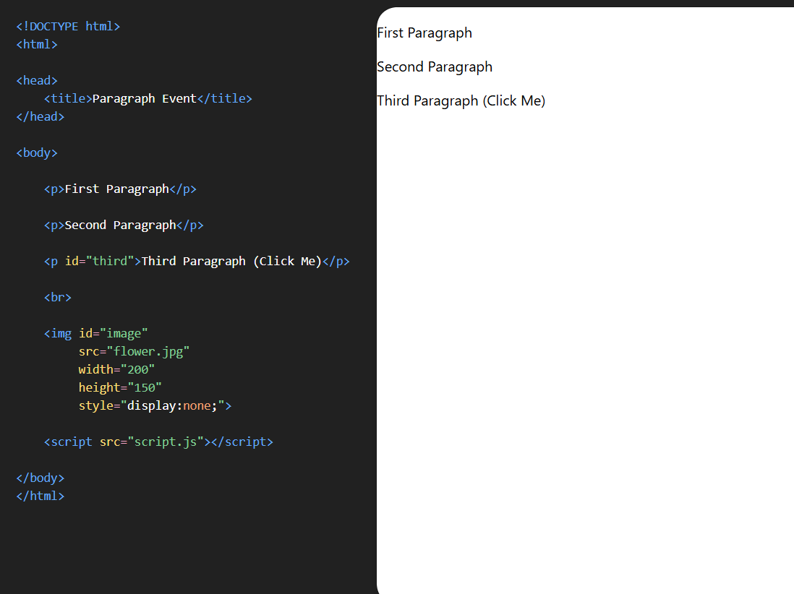

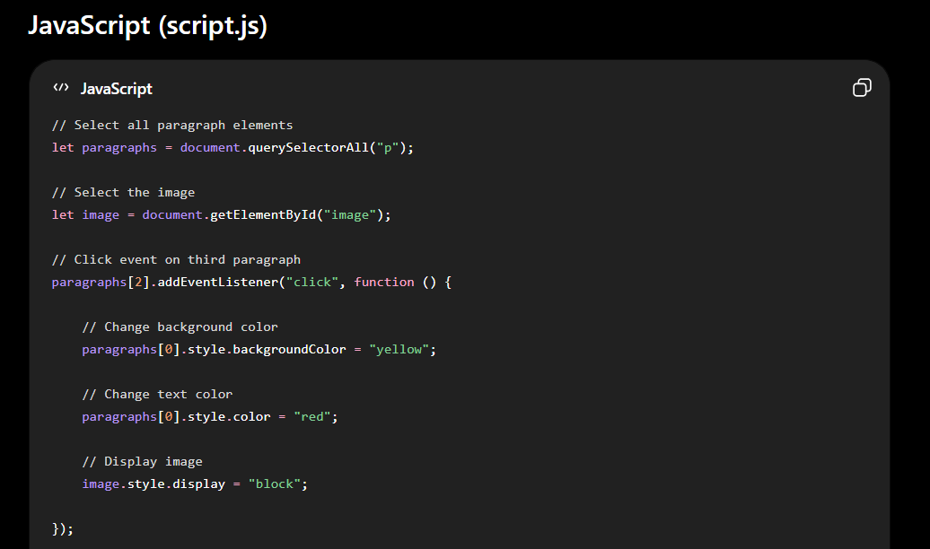
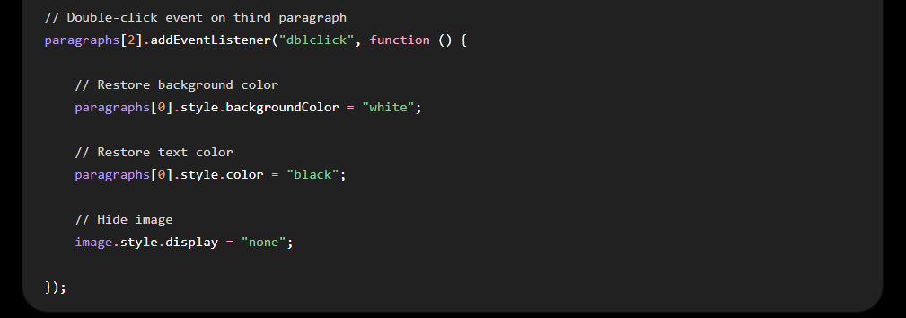

This is a 7-mark DOM Manipulation + Events question.
It tests:
- ✅ getElementById()
- ✅ querySelectorAll()
- ✅ addEventListener()
- ✅ click
- ✅ dblclick
- ✅ style.backgroundColor
- ✅ style.color
- ✅ style.display

HTML
<!DOCTYPE html>
<html>

<head>
<title>Paragraph Event</title>
</head>

<body>

<p>First Paragraph</p>

<p>Second Paragraph</p>

<p id="third">Third Paragraph (Click Me)</p>

<br>

<img id="image"
src="flower.jpg"
width="200"
height="150"
style="display:none;">

<script src="script.js"></script>

</body>
</html>

JavaScript (script.js)
// Select all paragraph elements
let paragraphs = document.querySelectorAll("p");

// Select the image
let image = document.getElementById("image");

// Click event on third paragraph
paragraphs[2].addEventListener("click", function () {

// Change background color
paragraphs[0].style.backgroundColor = "yellow";

// Change text color
paragraphs[0].style.color = "red";

// Display image
image.style.display = "block";

});

// Double-click event on third paragraph
paragraphs[2].addEventListener("dblclick", function () {

// Restore background color
paragraphs[0].style.backgroundColor = "white";

// Restore text color
paragraphs[0].style.color = "black";

// Hide image
image.style.display = "none";

});

Explanation (7 Marks)

1.
let paragraphs = document.querySelectorAll("p");
Selects all paragraph elements.

2.
let image = document.getElementById("image");
Selects the image element.

3.
paragraphs[2].addEventListener("click", function () {
Adds a click event to the third paragraph.

4.
paragraphs[0].style.backgroundColor = "yellow";
Changes the background color of the first paragraph.

5.
paragraphs[0].style.color = "red";
Changes the text color of the first paragraph.

6.
image.style.display = "block";
Displays the image.

7.
paragraphs[2].addEventListener("dblclick", function () {
Adds a double-click event to the third paragraph.

8.
paragraphs[0].style.backgroundColor = "white";
Restores the original background color.

9.
paragraphs[0].style.color = "black";
Restores the original text color.

10.
image.style.display = "none";
Hides the image.

Output

Initially
First Paragraph

Second Paragraph

Third Paragraph (Click Me)

(Image Hidden)

After Clicking the Third Paragraph
First Paragraph
Background → Yellow
Text → Red

Second Paragraph

Third Paragraph

Image Displayed

After Double-Clicking the Third Paragraph
First Paragraph
Background → White
Text → Black

Second Paragraph

Third Paragraph

Image Hidden
This is a complete 7-mark answer in the style your faculty expects, using addEventListener() throughout.

